 | Diagnostic Medicare  Center Management  Technical Design Document  1.0
 | Prepared By / Last Updated By | Reviewed By | Approved By
Name | Shubham Srivastava | Shivam Goel | Ashu Jauhari
Role | Team Member | Team Member | Scrum Master
Signature | Shubham Srivastava | Shivam Goel | Ashu Jauhari
Date | 04/12/2019 | 04/15/2019 | 04/16/2019

Table of Contents

1.0 Introduction 4
1.1 Purpose of this document 4
1.2 Scope 4
1.3 Intended Audience 4
1.4 Definition & Acronyms 4
2.0 Conventions and Standards Followed 5
3.0 Assumptions, Dependencies and Risks 5
3.1 Assumptions: 5
3.2 Dependencies: 5
4.0 Schematic Diagram 6
5.0 Use Case Realization 7
5.1.1 Customer Registration 7
a. Functional Requirement 7
b. UI Validations 7
c. UI Controls 7
d. UI Methods Definition 8
e. UI Design 8
5.1.2 Doctor Registration 9
a. Functional Requirement 9
b. UI Validations 9
c. UI Controls 9
d. UI Methods Definition 10
e. UI Design 11
5.1.3 Admin Registration 11
a. Functional Requirement 11
b. UI Validations 11
c. UI Controls 12
d. UI Methods Definition 12
e. UI Design 13
5.1.4 Customer, Doctor and Admin Credential Authentication 14
a. Functional Requirement 14
b. UI Validations 14
c. UI Controls 14
d. UI Methods Definition 14
e. UI Design 15
5.1.5 Update Medicare Service Details 15
a. Functional Requirement 15
b. UI Validations 15
c. UI Controls 15
d. UI Methods Definition 16
e. UI Des 16
e.UI Design 16
5.1.6 View Medicare Service 17
a. Functional Requirement 17
c. UI Design 17
5.1.7 Raise Checkup Request 18
a. Functional Requirement 18
b. UI Controls 18
c. UI Methods Definition 18
d. UI Design 19
5.1.8 Update Test Results 20
a. Functional Requirement 20
b. UI Validations 20
c. UI Controls 20
d. UI Methods Definition 21
e. UI Design 21
5.1.9 View Test Results 22
a. Functional Requirement 22
b. UI Design 22
5.1.10 Customer/Admin log off 23
a. Functional Requirement 23
b. UI Methods Definition 23
c. UI Design 23
6. Database Design 24
6.1 Data Model 24
The following is a schematic view of the database design 24
6.2 Tables Structure 24
7. Change Log 29

Introduction

Purpose of this document
The purpose of the detail design document is to define the detailed design for all the components of Diagnostic Medicare Center management that are specified in the Business Requirement/Use case document. All the low-level components, interfaces and integrations are detailed out in this document.

Scope
This sub-section shall state the scope of this detailed design document
• Create and maintain Customer information.
• Create and maintain Doctor information.
• Create and maintain Admin information.
• Create and maintain all medical services.

Intended Audience
The intended audience for this document is
- Developers, testers, other associates in the project
- Technical lead, Scrum Master
- Product Owner

Definition & Acronyms
Acronyms | Definitions
DMCM | Diagnostic Medicare Center management

Conventions and Standards Followed
The modules under scope needs to adhere to the coding standards and guidelines


Assumptions, Dependencies and Risks

Assumptions:
- Any changes to the design mentioned in the BRD would be taken as a Change Request

Dependencies:
- Availability of database design characteristics & access shall be defined by the
- Resource availability throughout each of the sprint

Schematic Diagram
A schematic, or schematic diagram, is a representation of the elements of a system using abstract, graphic symbols rather than realistic pictures. It gives an overview of overall system
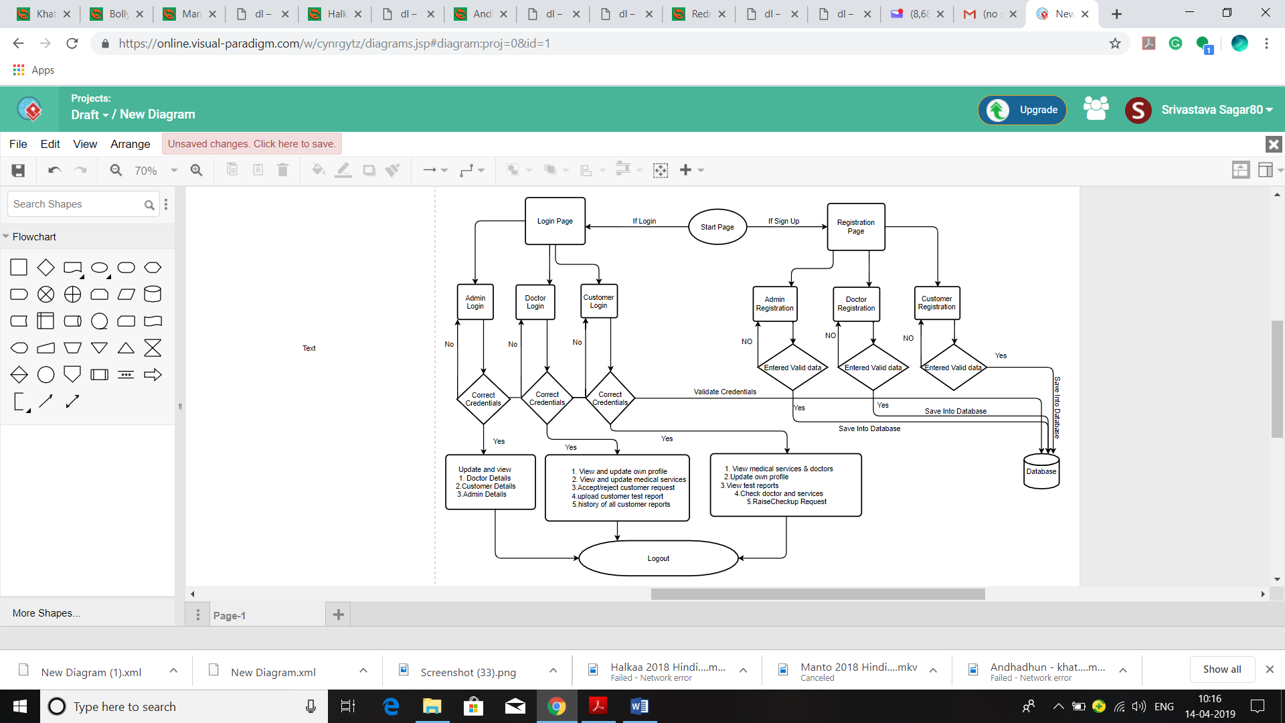
Figure 4.0 schematic Diagram

Use Case Realization

Customer Registration

Functional Requirement
This use case deals with the capture of customer details. The ‘customer’ here shall be the operator of the system and will be keying in the customer details.

UI Validations
- All fields are mandatory.
- The Email ID format must be checked.
- Phone Number must be of 10 digits’ length.
- Age should be 2-digit numeric value.
- First Name, Last Name should contain only alphabets.
- Gender should be chosen from the dropdown options.

UI Controls
# | UI Component | Type | Name | Details
1 | Customer ID | Text Field | Customer_Id | To enter customer id
2 | First Name | Text Field | First_Name | To enter first name  of the customer
3 | Last Name | Text Field | Last_Name | To enter last name  of the customer
4 | Age | Text Field | Age | To enter age  of the customer
5 | Gender | Drop Down | Gender | To select gender  of the customer
6 | DoB | Text Field | DOB | To enter dob of the customer
7 | Contact Number | Text Field | Contact_Number | To enter contact number of the customer
8 | Alt Contact Number | Text Field | Alternate_Contact_Number | To enter alt contact number of the customer
9 | Email ID | Text Field | Email_id | To enter email id of the customer
10 | Password | Password field | Password | To enter password  of the customer
11 | Address Line 1 | Text Field | Address_1 | To enter address line 1 of the customer
12 | Address Line 2 | Text Field | Address_2 | To enter address line 2 of the customer
13 | City | Text Field | City | To enter city of the customer
14 | State | Text Field | State | To enter state of the customer
15 | Zip Code | Text Field | Zip_code | To enter zip code  of the customer

UI Methods Definition
Method Name | Parameter | Details
Register_button | Object User | Allows the user to register his details

UI Design

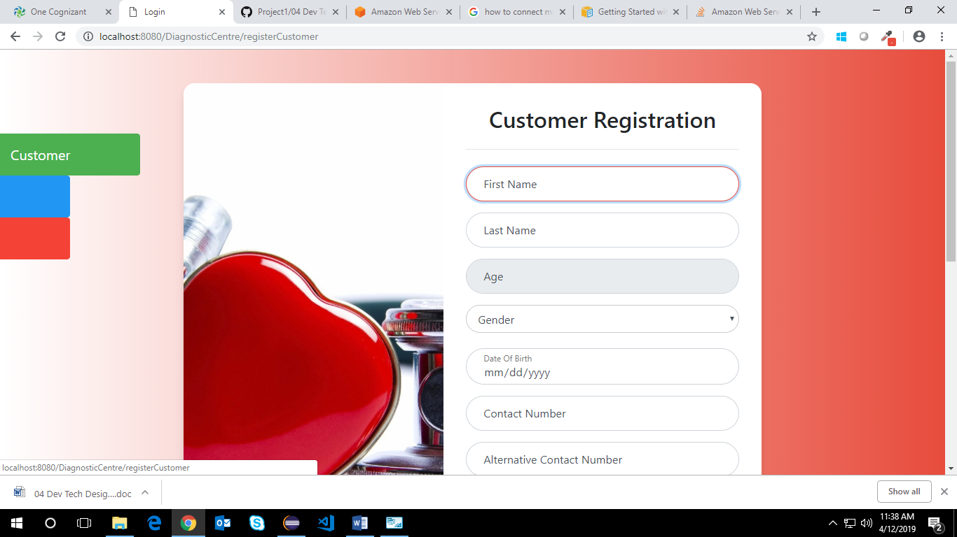
Figure 5.1.1 Customer Registration

Doctor Registration

Functional Requirement
This use case deals with the capture of doctor details. The ‘doctor’ here shall be the operator of the system and will be keying in the doctor details.

UI Validations
- All fields are mandatory.
- The Email ID format must be checked.
- Phone Number must be of 10 digits’ length.
- Age should be 2-digit numeric value.
- First Name, Last Name should contain only alphabets.
- Gender should be chosen from the dropdown options.

UI Controls
# | UI Component | Type | Name | Details
1 | Doctor ID | Text Field | Doctor_ID | To enter doctor id
2 | First Name | Text Field | First_Name | To enter first name of the doctor
3 | Last Name | Text Field | Last_Name | To enter last name of the doctor
4 | Age | Text Field | Age | To enter age of the doctor
5 | Gender | dropdown | Gender | To select gender of the doctor
6 | DoB | Text Field | DOB | To enter dob of the doctor
7 | Contact Number | Text Field | Contact_Number | To enter contact number of the doctor
8 | Alt Contact Number | Text Field | Alternate_Contact_Number | To enter alt contact number of the doctor
9 | Email ID | Text Field | Email_id | To enter email id of the doctor
10 | Password | Password Field | Password | To enter password of the doctor
11 | Address Line 1 | Text Field | Address_Line1 | To enter address line 1 of the doctor
12 | Address Line 2 | Text Field | Address_Line2 | To enter address line 2 of the doctor
13 | City | Text Field | City | To enter city of the doctor
14 | State | Text Field | State | To enter state of the doctor
15 | Zip Code | Text Field | Zipcode | To enter zip code of the doctor
16 | Degree | Text Field | Degree | To enter degree of the doctor
17 | Specialty | Text Field | Specialty | To enter specialty of the doctor
18 | Work hours | Text Field | Work_hours | To enter work hours of the doctor
19 | Hospital/Clinic Name | Text Field | Hospital | To enter hospital/clinic name of the doctor
20 | Medicare Service ID | Text Field | Medical_Service_Id | To enter medicare service id

UI Methods Definition
Method Name | Parameter | Details
Register_button | Object User | Allows the doctor to register his details

UI Design

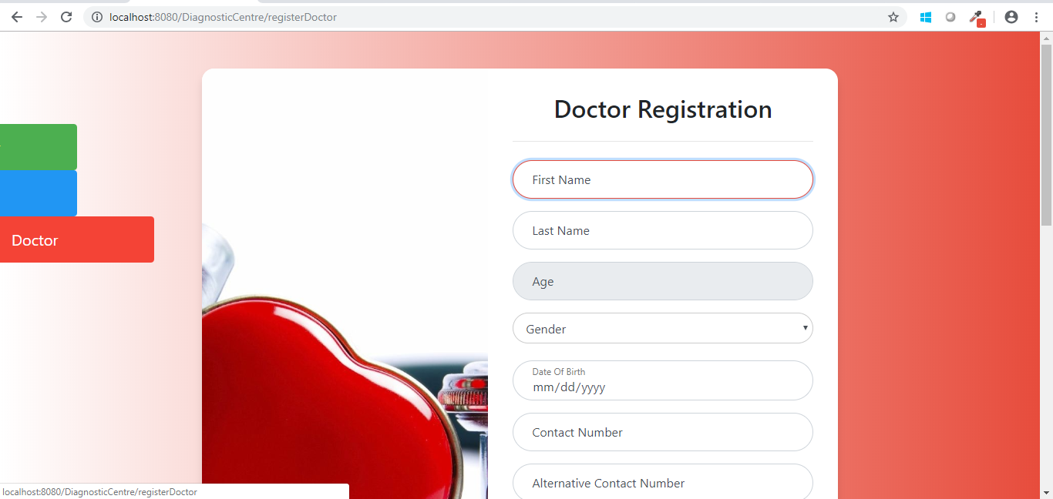
Figure 5.1.2 Doctor Registration

Admin Registration

Functional Requirement
This use case deals with the capture of admin details. The ‘admin’ here shall be the operator of the system and will be keying in the admin details.

UI Validations
- All fields are mandatory.
- The Email ID format must be checked.
- Phone Number must be of 10 digits’ length.
- Age should be 2-digit numeric value.
- First Name, Last Name should contain only alphabets.
- Gender should be chosen from the dropdown options.

UI Controls
# | UI Component | Type | Name | Details
1 | Admin ID | Text Field | Admin_ID | To enter admin id
2 | First Name | Text Field | First_Name | To enter first name of the admin
3 | Last Name | Text Field | Last_Name | To enter last name of the admin
4 | Age | Text Field | Age | To enter age of the admin
5 | Gender | dropdown | Gender | To select gender of the admin
6 | DoB | Text Field | DOB | To enter dob of the admin
7 | Contact Number | Text Field | Contact_Number | To enter contact number of the admin
8 | Alt Contact Number | Text Field | Alternate_Contact_Number | To enter alt contact number of the admin
9 | Email ID | Text Field | Email_id | To enter email id of the admin
10 | Password | Password Field | Password | To enter password  of the admin

UI Methods Definition
Method Name | Parameter | Details
Register_button | Object User | Allows the admin to register his details

UI Design
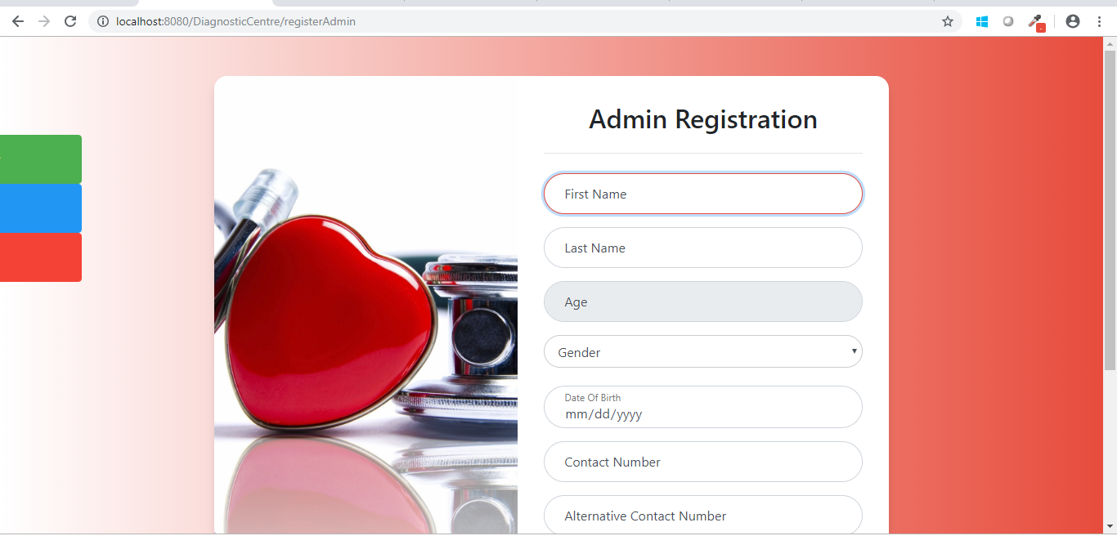
Figure 5.1.3 Admin Registration

Customer, Doctor and Admin Credential Authentication

Functional Requirement
. Login Page checks the authentication of the user and based on his role, directs the user to the respective page.

UI Validations
- User Id and Password fields are mandatory.
- Invalid User Id and / or password should not allow the user to get into the system

UI Controls
# | UI Component | Type | Name | Details
1 | Your Id | Text Field | username | To enter username
2 | Your Password | password | password | To enter password

UI Methods Definition
Method Name | Parameter | Details
Login_Button | Object User | Allows the user to login into the portal
Register_Button | None | Allows the user to register his details

UI Design

Figure 5.1.4 Customer, Doctor and Admin Credential Authentication

Update Medicare Service Details

Functional Requirement
This use case deals with the ability to update Medicare service details by doctor. The ‘doctor’ here shall be the operator of the system and will be update the details.

UI Validations
- All fields are mandatory.
- In Amount field you can enter only numeric value.

UI Controls
# | UI Component | Type | Name | Details
1 | Medicare Service ID | Text Field | medicare_service_id | To enter medicare service id by doctor
2 | Medicare Service | Text Field | medicare_service | To enter Medicare service by doctor
3 | Service Description | Text Field | service_description | To enter service description by doctor
4 | Amount | Text Field | amount | To enter amount by doctor
5 | Diagnostic 1 Normal Range | dropdown | D1_Range | To enter diagnostic 1 normal range by doctor
6 | Diagnostic 2 Normal Range | Text Field | D2_Range | To enter diagnostic 2 normal range by doctor

UI Methods Definition
Method Name | Parameter | Details
Update | Object User | Allows the update the Medical service details.
Close | None | Allows the doctor to close the update request form.

UI Des

e.UI Design

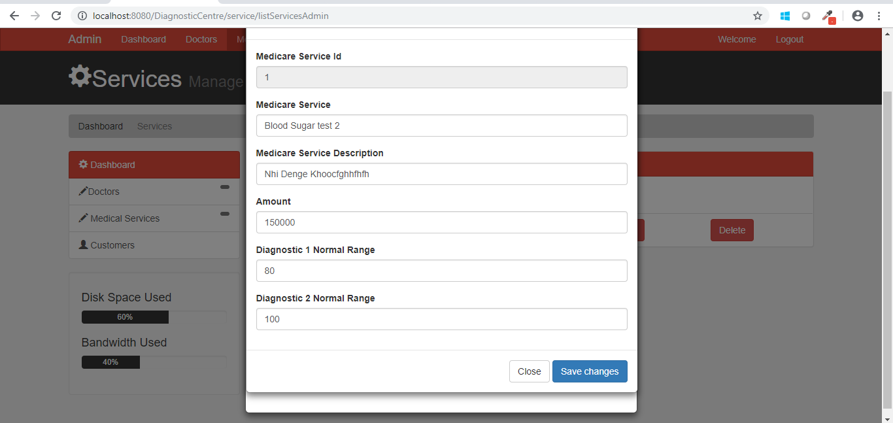
Figure 5.1.5 Update Medicare Service Details

View Medicare Service

Functional Requirement
This use case deals with the ability to View the available Medical services to the customer. The ‘customer’ here shall be the operator of the system and will view the Medicare service details.

- UI Methods Definition
Method Name | Parameter | Details
View | Object User | Allows the customer to view details of Medicare service details.

UI Design
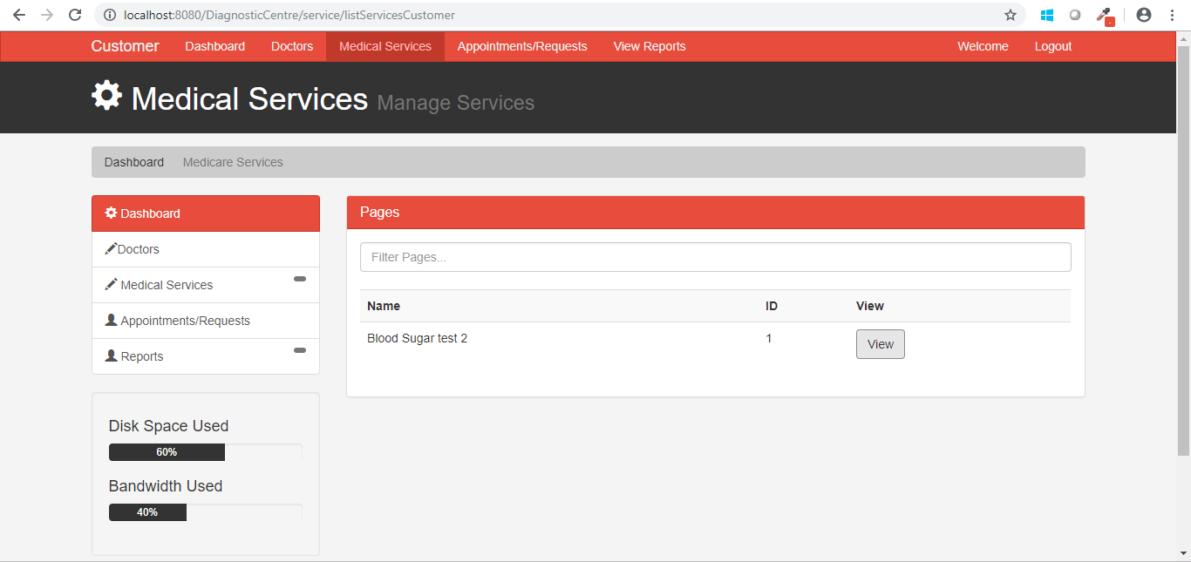
Figure 5.1.6 View Medicare Service

Raise Checkup Request

Functional Requirement
. This use case deals with raising checkup request to the doctor by the customer. The ‘customer’ here shall be the operator of the system and will be keying in the checkup request details.
UI Validations
- Date should be entered in the specified format.

UI Controls
# | UI Component | Type | Name | Details
1 | Doctor ID | Text Field | Doctor_ID | To enter doctor id by the customer
2 | Date | Text Field | Date | To enter the date by the customer
3 | Service Id | Text Field | Service_ID | To enter the service id by the customer

UI Methods Definition
Method Name | Parameter | Details
Request_button | Object User | Allows the customer to send the request to the doctor.
Close_button | None | Allows the customer to close the Appointment request form.

UI Design
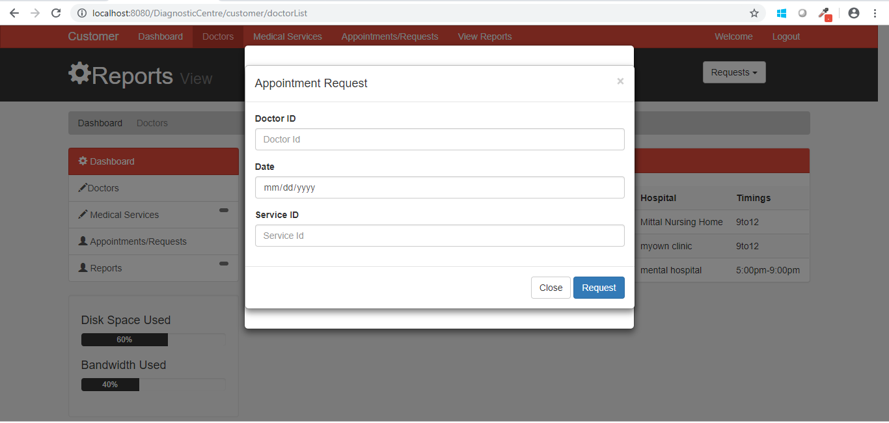
Figure 5.1.7 Raise Checkup Request

Update Test Results

Functional Requirement
. This use case deals with updating the test results by the doctor. The ‘doctor’ here shall be the operator of the system and will update the test results of the customers.

UI Validations
- All fields are mandatory.
- Enter the data in the specified format else will give the error.

UI Controls
# | UI Component | Type | Name | Details
1 | ID | Text Field | ID | To enter id by the doctor
2 | Diag 1 Actual Value | Text Field | D1_Actual_value | To enter diag 1 actual value by the doctor
3 | Diag 1 Normal Range | Text Field | D1_Normal_value | To enter diag 1 normal range by the doctor
4 | Diag 2 Actual Value | Text Field | D2_Actual_value | To enter diag 2 actual value by the doctor
5 | Diag 2 Normal Range | Text Field | D2_Normal_value | To enter diag 2 normal range by the doctor
6 | Comments | Text Field | Doctor_Comments | To enter comments by the doctor
7 | Other info. | Text Field | Other_Information | To enter other info. by the doctor

UI Methods Definition
Method Name | Parameter | Details
Update_button | Object User | Allows the update the test results.
Close_button | None | Close the update form of the test results

UI Design
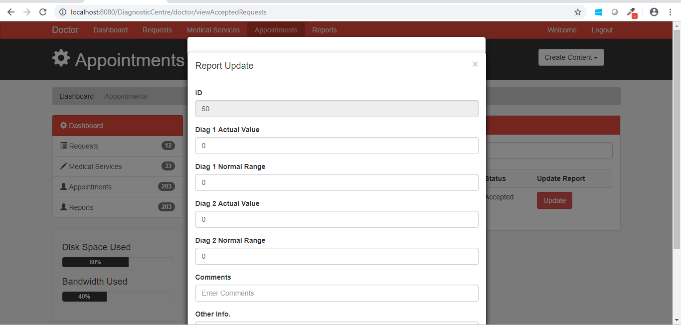
Figure 5.1.8 Update Test Results

View Test Results

Functional Requirement
. This use case deals with View of test results to the customers. The ‘customer’ here shall be the operator of and view the results of their treatment.

UI Design
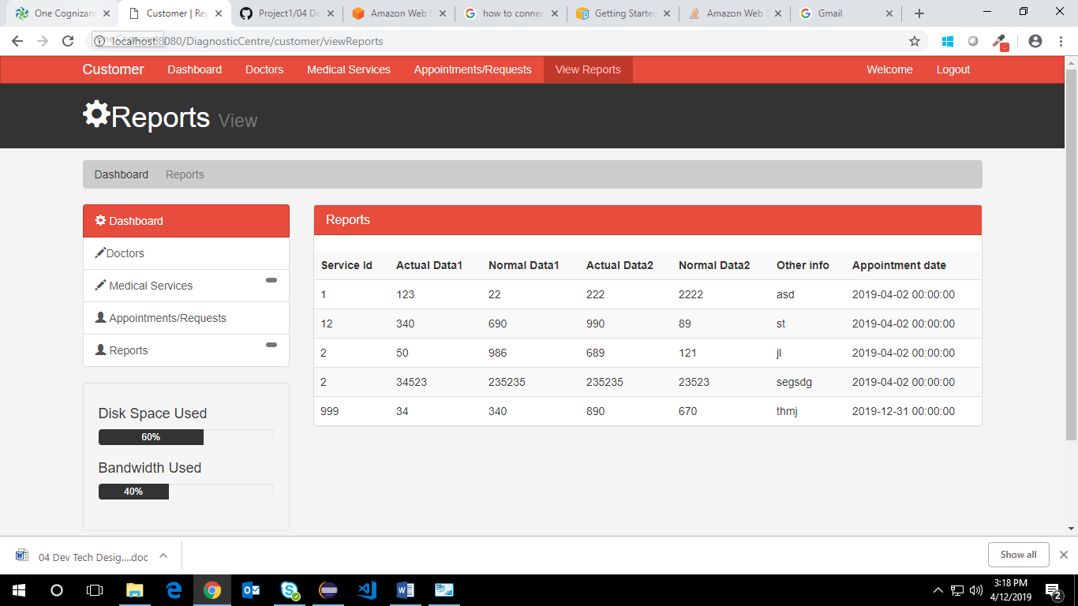
Figure 5.1.9 View Test Results

Customer/Admin log off

Functional Requirement
. This use case deals with log off of customer/ admin. The ‘customer/admin’ here shall be the operator of the system and will gets log off from the system whenever they want.

UI Methods Definition
Method Name | Parameter | Details
Logout_button | Object User | Allows the user to get log off from the system

UI Design
Figure 5.1.10 Customer/Admin log off

Database Design

Data Model

The following is a schematic view of the database design
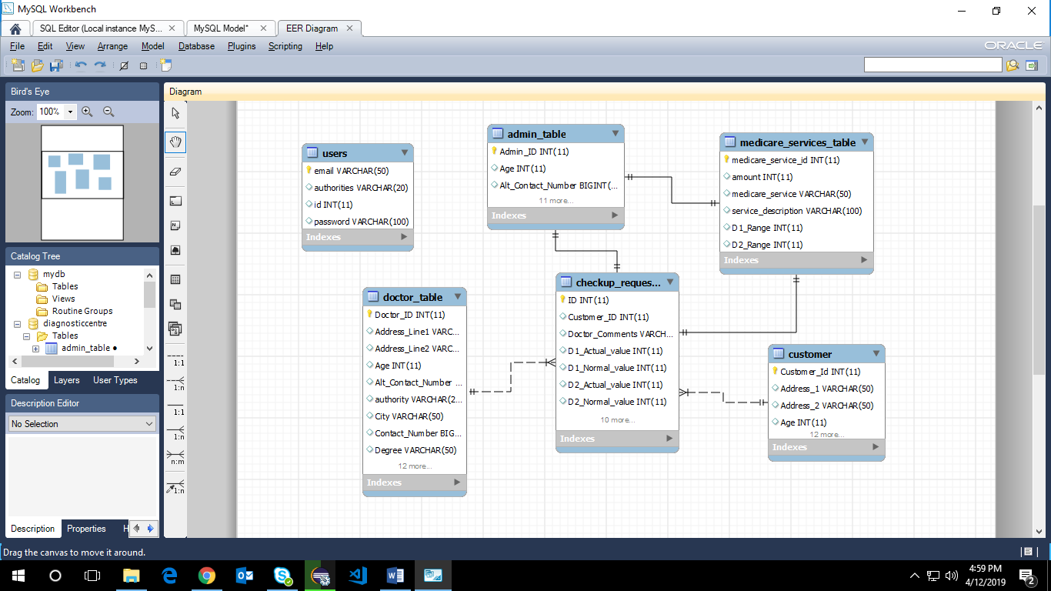

Tables Structure
Customer Registration:
Column Name | Data Type | Length | Nulls
Customer ID | Alphabetic | 10 | N
First Name | Alphabetic | 50 | N
Last Name | Alphabetic | 50 | N
Age | Numeric | 2 | N
Gender | Drop Down | NA | N
DoB | Alphanumeric | 10 | Y
Contact Number | Numeric | 10 | N
Alt Contact Number  Email ID | Numeric  Alphanumeric | 10  50 | Y  N
Password | Alphanumeric | 15 | N
Address Line 1 | Alphanumeric | 100 | N
Address Line 2 | Alphabetic | 100 | Y
City | Alphabetic | 50 | N
State | Alphabetic | 50 | N
Zip Code | Numeric | 10 | N

Doctor Registration:
Column Name | Data Type | Length | NULLS
Doctor ID | Alphabetic | 10 | N
First Name | Alphabetic | 50 | N
Last Name | Alphabetic | 50 | N
Age | Numeric | 2 | N
Gender | Drop Down | NA | N
DoB | Alphanumeric | 10 | Y
Contact Number | Numeric | 10 | N
Alt Contact Number | Numeric | 10 | Y
Email ID | Alphanumeric | 50 | N
Password | Alphanumeric | 15 | N
Address Line 1 | Alphanumeric | 100 | N
Address Line 2 | Alphabetic | 100 | Y
City | Alphabetic | 50 | N
State | Alphabetic | 50 | N
Zip Code | Numeric | 10 | N
Degree | Alphabetic | 50 | N
Specialty | Alphabetic | 50 | N
Work hours | Drop down | NA | N
Hospital/Clinic Name | Alphanumeric | 100 | N
Medicare Service ID | Numeric | 10 | N

Admin Registration:
Column Name | Data Type | Length | NULLS
Admin ID | Alphabetic | 10 | N
First Name | Alphabetic | 50 | N
Last Name | Alphabetic | 50 | N
Age | Numeric | 2 | N
Gender | Drop Down | NA | N
DoB | Alphanumeric | 10 | Y
Contact Number | Numeric | 10 | N
Alt Contact Number | Numeric | 10 | Y
Email ID | Alphanumeric | 50 | N
Password | Alphanumeric | 15 | N

Medicare Services:
Column Name | Data Type | Length | NULLS
Medicare Service ID | Numeric | 10 | N
Medicare Service | Alphabetic | 50 | N
Service Description | Alphabetic | 200 | N
Amount | Numeric | 10 | N

Medical Test History:
Column Name | Data Type | Length | NULLS
Report ID | Numeric | 10 | N
Customer ID | Alphabetic | 10 | N
Doctor ID | Alphabetic | 10 | N
Medicare Service ID | Numeric | 10 | N
Agent ID | Alphabetic | 10 | N
Service date  Test Result date | Alphanumeric  Alphanumeric | 10  10 | N  N
Diag 1 – Actual Value | Numeric | 10 | N
Diag 1 – Normal Range | Numeric | 10 | N
Diag 2 – Actual Value | Numeric | 10 | Y
Diag 2– Normal Range | Numeric | 10 | Y
Diag 3 – Actual Value | Numeric | 10 | Y
Diag 3 – Normal Range | Numeric | 10 | Y
Diag 4 – Actual Value | Numeric | 10 | Y
Diag 4 – Normal Range | Numeric | 10 | Y
Diag 5 – Actual Value | Numeric | 10 | Y
Diag 5 – Normal Range | Numeric | 10 | Y
Diag 6 – Actual Value | Numeric | 10 | Y
Diag 6 – Normal Range | Numeric | 10 | Y
Doctors Comments | Alphabetic | 300 | N
Other info | Alphabetic | 300 | Y

Change Log
Please note that this table needs to be maintained even if a Configuration Management tool is used.
Version Number | Changes made
V1.0 | <First version>
V1.1 | <If the change details are not explicitly documented in the table below, reference should be provided here>
V1.1 | Page no | Changed by | Effective date | Changes effected
V1.2 | <If the change details are not explicitly documented in the table below, reference should be provided here>
V1.2 | Page no | Changed by | Effective date | Changes effected

